**Experiment No. 1.1 Paul Thomas 30 S3 CSB**

Program

| /*command line arguement type*/  class palindrome{    public static void main(String [] args){  String Str = args[0];  String rev = "";  int length = Str.length();  for(int i=length-1; i>=0; i--){  rev = rev + Str.charAt(i);  }  System.out.println("\nReversed String is " + rev);  if(Str.equals(rev)){  System.out.println("Palindrome");  }  else{  System.out.println("Not Palindrome");  }  }  } |
| --- |

Program

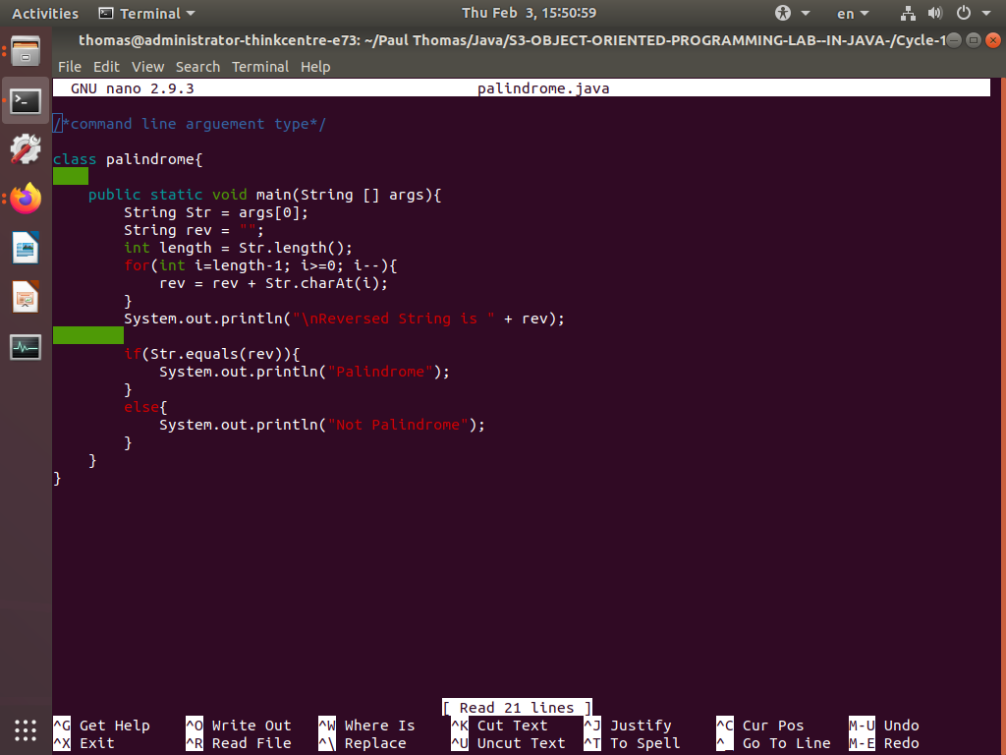

Output

